Wednesday 22nd April 2020
LK: To identify articles and improve simple sentences.
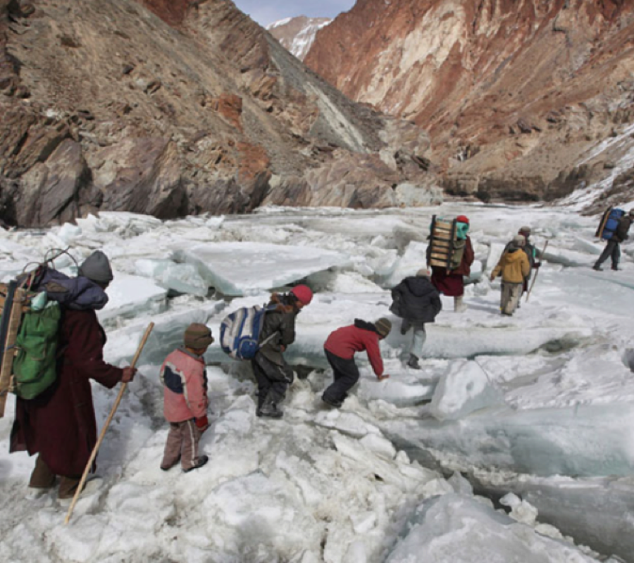

Sentence Challenge
Can you identify the articles in these sentences?
- The children walked across the ice.
- They heard an almighty crunch beneath their feet!
- A tall mountain stood right in front of them.
Can you identify the articles you have used in your writing today?
Sick Sentences
These sentences are ‘sick’ and need help to get better. Can you help? Could you add an adverb?
It was very early. We walked across the ice. It was cold.

Email your work to WDV.Year5@oasiswoodview.org if you would like any feedback.

