Friday 3rd April 2020
LK: To write a story based on an illustration.
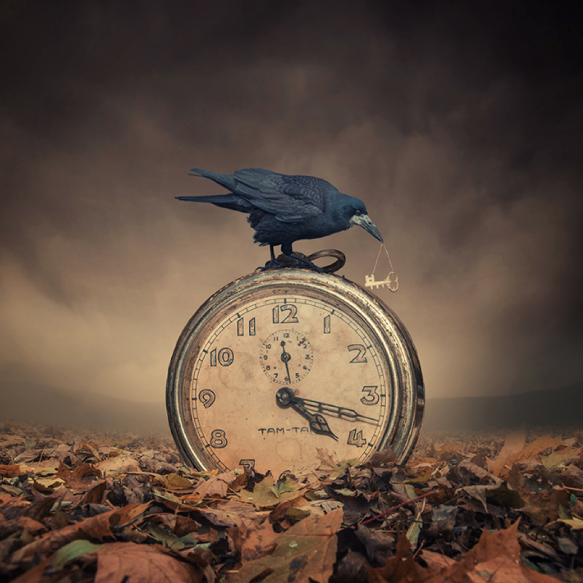

Story Starter

She had been chasing it all day. Now, the crow had it.

Time was ticking. Time was running out. She tiptoed towards the creature, seeing the precious key it held precariously in its sharp, cruel beak. It let out an irritating, throaty cackle, its soot-black wings ruffling gently as it manoeuvred itself on top of the clock; it was ready to take flight.

Knowing she might only have a few seconds before her opportunity disappeared, she took another cautious step forward. Time seemed to slow, her body tingled in excitement and her heart thudded in her chest. It was now or never…

Your Task: Can you continue the story?

You may want to include any elements you used yesterday from your setting description. Also, try to include a range of Alan Peat sentence types to engage the reader.

