Thursday 23rd April
L.K: To use short division methods to calculate reasoning and problem solving
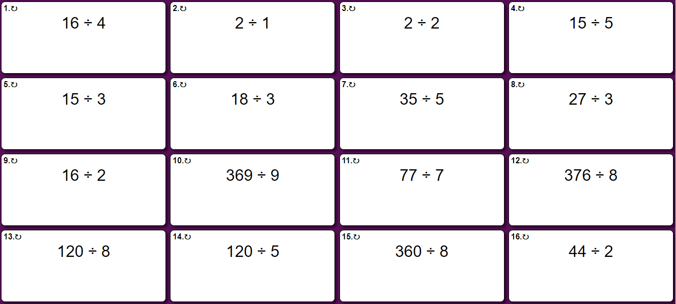
Try these starter questions to develop your understanding of short division.
The answers will be at the bottom of the document!
Try these reasoning and problem solving questions to develop greater understanding of bus stop method.
One Star
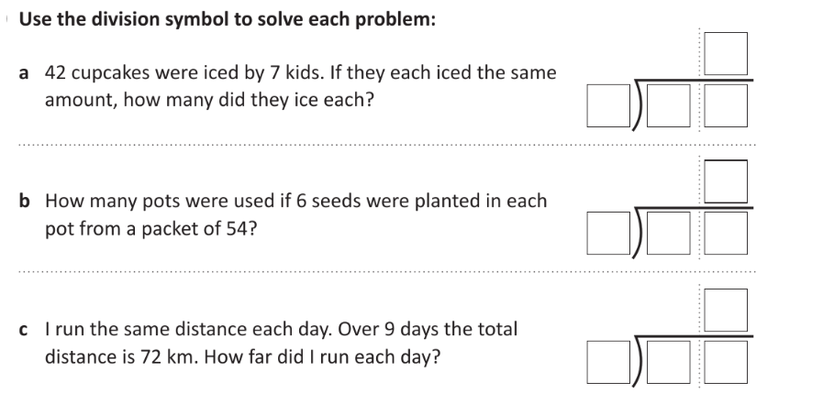
Two Star
- Rosie writes, 85 ÷ 3 = 28 r 1. She says “85 must be 1 away from a multiple of 3” Do you agree?
- Dora is calculating 72 ÷ 3. Before she starts, she says the calculation will involve an exchange. Do you agree? Explain why using bus stop method.
- There are 458 leaves split between 6 trees. How many leaves are on each tree?
Three Star
- Eva has 96 sweets. She shares them into equal groups. She has no sweets left over. How many groups could Eva have shared her sweets into?
- 37 sweets are shared between 4 friends. How many sweets are left over? Four children attempt to solve this problem.
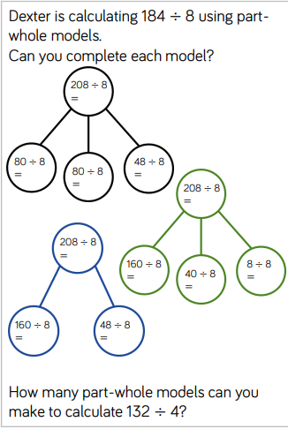
• Alex says it’s 1
• Mo says it’s 9
• Eva says it’s 9 r 1
• Jack says it’s 8 r 5
Can you explain who is correct and the mistakes other people have made?

Extension

