Thursday 2nd April
L.K: Continued recap of column addition and subtraction
Try these starter questions first. Make sure for each question to provide a written explanation of how you calculated each answer. This will help you to identify any mistakes and make sure that you are solid in your understanding the method!
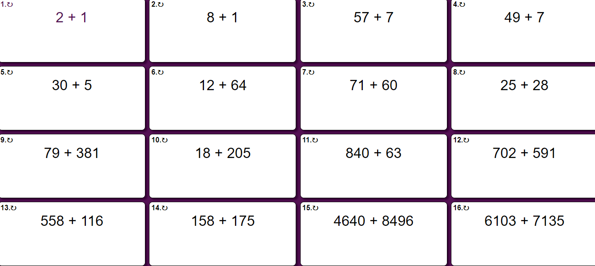
The answers will be on the bottom of the page. It is up to YOU to make sure that you are being honest, as you will only be cheating yourself if you look before you complete them!
Reasoning and Problem Solving
ONE STAR
- I buy 1300 loaves of bread from a bakery. If my friend buys 1250 more, how many loaves of bread will we have in total?
- Mrs Northall writes the number 1675 on the board. Ritaj writes the number 2345 on the board. What would be the total number if they added these numbers together?
- I have 9654 oranges. If I eat 4000 oranges, how many will I have left?
TWO STAR
- A Parisian bakery bakes 2645 baguettes in the morning and had sold 1927 by lunchtime. How many baguettes were left?
- One Tuesday morning, 4378 people visited Notre Dame Cathedral. On Tuesday afternoon, 2695 more people visited the cathedral. How many visited during the whole of Tuesday?
- I need to buy 9000 plastic balls to put in my ball pit. After filling up the ball pit, a windy day leaves me with 4340 balls left. How many more balls do I need to fill up the ball pit again?
- A squirrel hides 3450 nuts to eat later. If 1736 nuts are found and eaten:
a) How many nuts does the squirrel need to replace?
b) How many nuts does the squirrel have left?
THREE STAR
- Whilst eating my lunch, I am attacked by bees! I estimate that there are 9500 bees surrounding me, but a rainstorm blows most of the bees away. I estimate that 4200 bees are left. How many bees are blown away by the rainstorm?
- A 2000g bag of food is eaten by a Hamster A in a month. A smaller hamster, Hamster B, eats 1650g of food. How much more food does Hamster A eat than Hamster B?
- A battleship has 1936 crew members for a journey to Southampton. 650 crew members leave when they get there and 396 crew members get on board the ship.
A) How many crew members are on the ship when it leaves Southampton?
B) Is this more or less crew members that were on at the start? How many?
EXTENSION
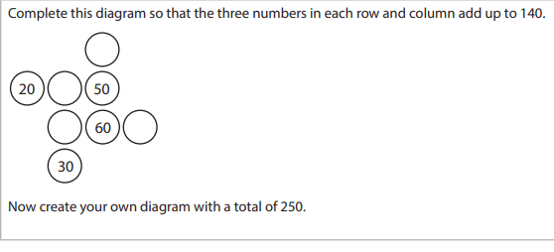

ANSWERS
