Topic, Science and Spanish Activities
Week Beginning 20th April 2020
Scrumdiddlyumptious
We are staying with our very first topic of the year for this week’s home learning tasks!
- Can you think of a type of food for every letter from A-Z? If you like you can illustrate this and make your own dictionary of food and drink.
- Look at the food that is in your kitchen. Can you find out where some of the items of food are grown or where they are imported from? You could draw a map to show this if you like too.
Science- Movement and Feeding
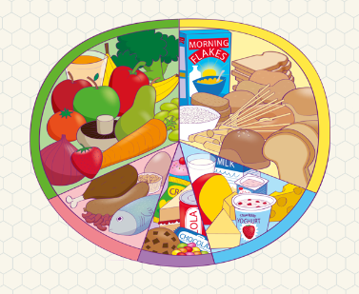
Remember the healthy eating plate?
Using this as a guideline can you plan out a healthy meal for yourself including some of your favourite things to eat? You might even like to plan a meal for a family member, or look at the food that is in your kitchen at home!
The names of the food groups you need to include are: Fruit and Vegetables, Carbohydrates (bread, potatoes, pasta etc), Protein (meat and fish), Dairy (milk and cheese), and don’t forget some treats of course!
Spanish
1 | uno | oo-no
2 | duo | do-o
3 | tres | treys
4 | cuatro | cwatro
5 | cinco | sinko
6 | seis | says
7 | seite | see-et-ey
8 | ocho | ocho
9 | nueve | nu-ev-ey
10 | diez | dee-ez

Can you practise these at home with a member of your family?

Don’t forget- you can get help with your work or send pictures of what you have been doing by emailing wdv.year3@oasiswoodview.org

