Comprehension: 7+ years

Pugs of the Frozen North
Winter came in the night, like a white sheet laid over the world. It came so cold and so fast that the waves of the ocean froze as they rolled. The good ship Lucky Star froze with them, trapped tight in the suddenly solid sea.
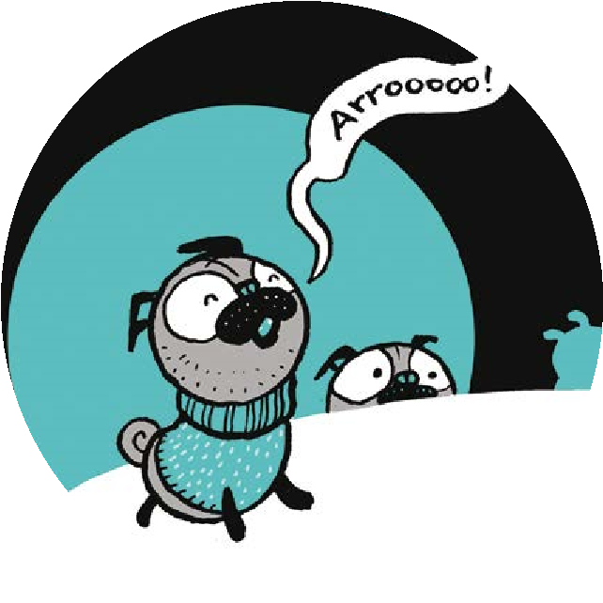
Shen the cabin boy, the youngest member of the crew, stirred in his sleep as the sounds of rippling and splashing faded into frozen silence. He snuggled deeper 5 under the covers, trying to keep warm. Into the silence came other noises. First, the creaking of metal as the ice tightened its grip upon the old ship’s sides.
Then the voice of Captain Jeggings, bellowing, ‘All hands on deck!’
The crew bumbled blinking from their bunks. Able Seaman Bo, Mungbean the ship’s cook, and Shen. They stumbled out on deck and stared at the frozen 10 waves which reared up all around them, stiff and white as giant meringues.
‘Don’t just stand there!’ shouted Captain Jeggings, hauling on an icy rope. ‘Get us out of here!’
The rope snapped in his hands with a sound like breaking glass.
The Lucky Star groaned and quivered as the ice clenched tighter. 15 ‘What shall we do?’ asked Shen.
But Captain Jeggings didn’t know. Nor did Able Seaman Bo. Nor did Mungbean. They’d weathered storms and sat out calms, but they’d never seen a sea like this before.
Creak. Crunch. Big tusks of ice pushed the planks apart and pierced the 20 Lucky Star’s sides. Slosh. Gurgle. Cold black water which hadn’t frozen yet came swirling in. The ship sagged, and all the icicles that decked her rigging tinkled cheerfully. But Captain Jeggings couldn’t see anything to be cheerful about.
‘The cargo!’ he shouted. ‘We must save the cargo!’
All summer long, the Lucky Star had been cruising from port to port, selling 25 this and buying that. Two thousand chunky-knit jumpers from the Isles of Aran, a second-hand snowmobile— and sixty-six pugs. Captain Jeggings had said those
tiny dogs would sell like hot pies. Now, down in
the leaking hold, they set up a terrible howling 30 as cold sea sloshed round their paws.
From Pugs of the Frozen North, by Philip Reeve and Sarah McIntyre
1

www.oxfordowl.co.uk
Activities based on pages 1-3 from Pugs of the Frozen North,
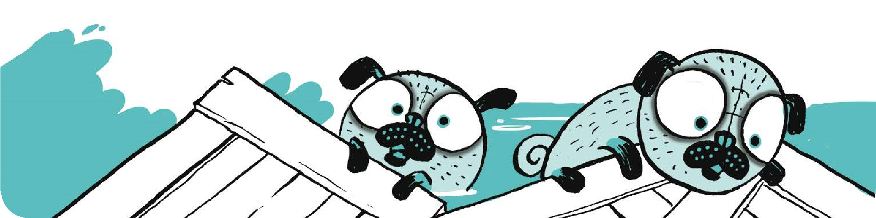
www.oxfordowl.co.uk
Activities based on pages 1-3 from
Pugs of the Frozen North
,
by Philip Reeve and Sarah McIntyre, ISBN 9780192734921

Artwork © Sarah McIntyre.

© Oxford University Press 2017
3
Comprehension:
years
7+
Questions
Extra activities

Continue the story, writing about what happens next.
What do you think happens to the pugs?

What similes could you use to describe weather conditions?
Describe a wintery or summer’s day you have experienced.
2
Read the story on page 1.
1
.
What do the words ‘suddenly solid sea’ at the end of the first paragraph tell us?
.
2
Why is the phrase ‘like a white sheet laid over the world’ effective?
3
.
How do the sounds heard by the cabin boy change overnight?
.
4
How can the reader tell that the cabin boy does not want to get up?
.
5
What do the words ‘bumbled blinking from their bunks’ suggest about how
the crew are feeling? Why are they effective?
.
6
When the Captain holds the rope, what happens?
.
7
Describe the appearance of the sea in this passage.
.
8
What do the words ‘groaned and quivered’ in line 15 show us about the ship?
9
.
Are the crew used to dealing with this kind of weather? How do you know?
10
. What is meant by ‘cargo’?
11
. Do you think that this is a well-organized trip? Why?
12
. How do you think the Captain is feeling about the situation.

