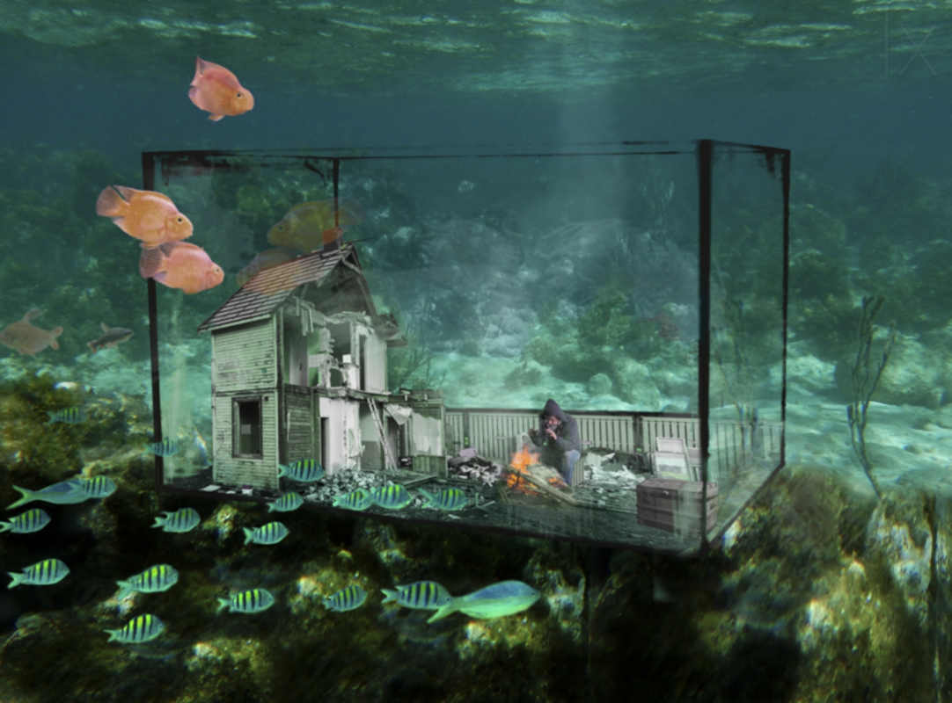

Sean was the only person who had taken notice of the warning. A great flood had swept over the planet, and now life was very different.
Can you continue the story?

