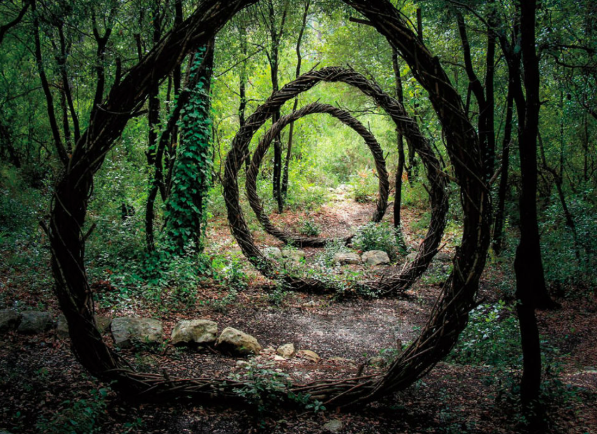

She had been tracking the deer. Her parents had taught her how.
One hour before, finding the hoof prints in the soft earth, she had followed the trail of broken twigs and occasional nibbled leaf until she had located it. Creeping slowly and quietly, not making even the slightest sound, she remained undetected.
She had stumbled across the mysterious circles in a clearing in the forest, and watched as the deer approached them. With a slight twitch of its ears, the deer stepped indifferently through the first circle, and vanished. Completely vanished.
The girl let out a gasp, and walked towards the circles to investigate…
Can you continue the story? Does the girl step through the circle?

