Week 2 – Topic – Year 1
Project Dinosaur.
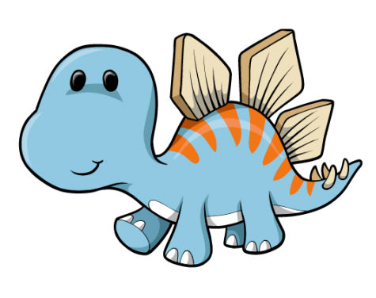
This week you will be researching your favourite dinosaur and having a dinosaur presentations. Maybe you could make dinosaur cookies for everyone to enjoy on Friday too!
Thursday
Find out which prehistoric era did your dinosaur live in?
Triassic, Jurassic and cretaceous.
What were the conditions of that era? Dry, wet, green, hot or cold.
Draw a picture to show.
Friday
Present all your findings and fantastic pictures and maps to your family and tell them everything you have found out.
Monday
Choose a dinosaur to research.
Draw a picture of your chosen dinosaur and write their name.
Tuesday
Find out if your dinosaur was a carnivore, herbivore or omnivore?
Draw their favourite dinner.
Wednesday
Find out which part of the world your dinosaur used to live.
Can you remember all the continents of world?

Print off a world map and draw where your dinosaur lived

