Week 2 – English – Year 1
Monday
The Blue Umbrella
Watch the short Pixar clip The Blue Umbrella on YouTube.
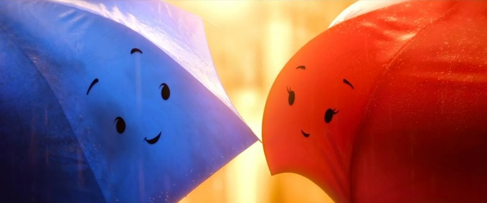
Characters
Blue Umbrella
Red Umbrella

Think about what the Blue Umbrella and the Red Umbrella are talking about at the café.
Success Criteria:
- To verbally discuss ideas of what the characters could be talking about.
- To write sentences using finger spaces, capital letters and the correct punctuation mark.
- To check and edit sentences.

