Week 12 – English- Year 1 Tuesday
Based on The Lighthouse Keeper’s Lunch… Write a book review:
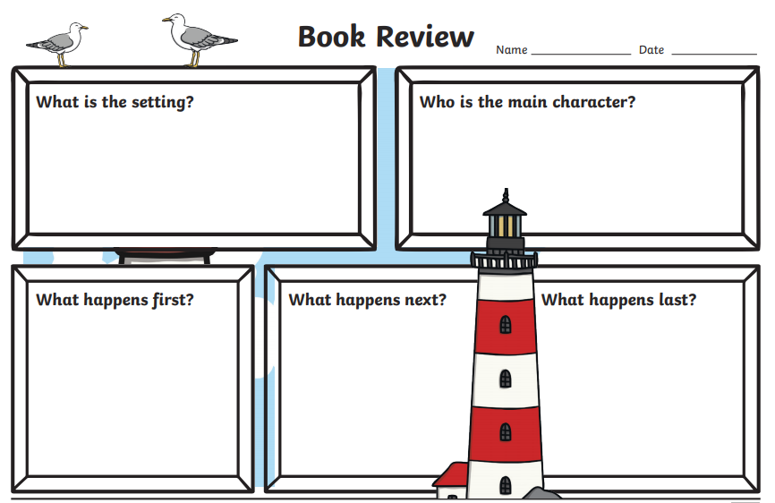
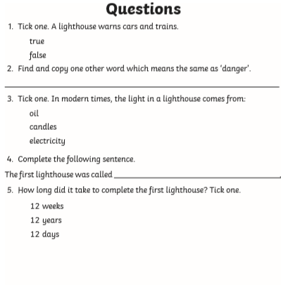
Extension - Reading Comprehension:
