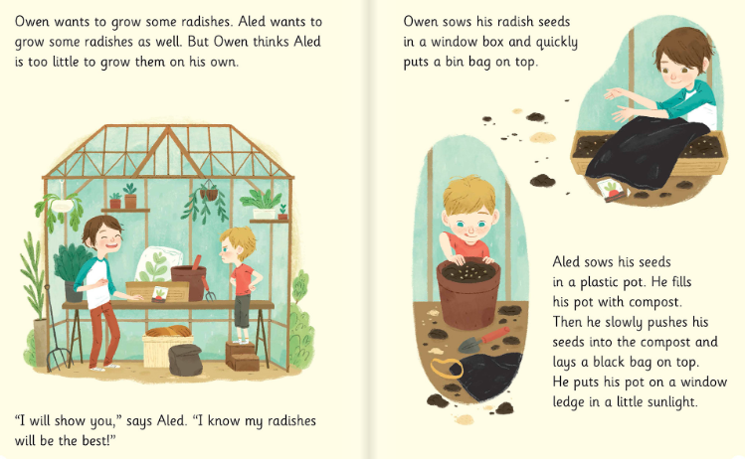
Week 10 – English- Year 1 Thursday Reading

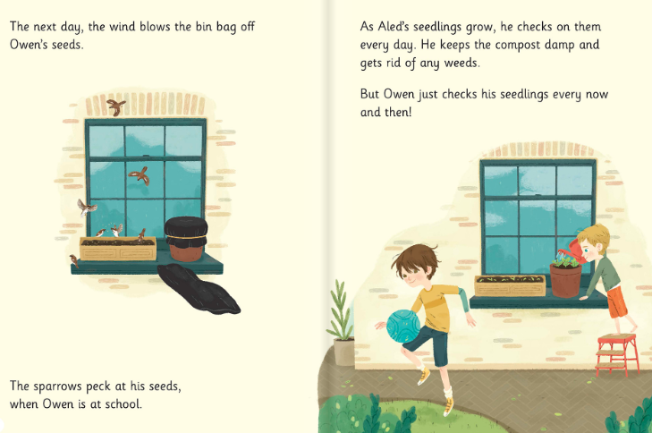

Questions:

1. What do Owen and Aled plant?

2. Who says ‘I know my radishes will be the best?

3. Where did Owen put is radish seeds?

4. Why did he put the seeds by the window box?

5. Can you find three two syllables words in the story?

