o

**Maths**

In Maths, we are exploring place value. Focus areas include: identifying values of digits, reading and writing numbers to 1 million, rounding, Roman numerals and interpreting negative numbers in context.

**Science**

In science, Year 5 are living about living things and their habitats. We look at the 7 life processes, the life cycle of plants, birds, amphibians and mammals. Additionally, we discuss reproduction and development of human life stages.

**English**

In Autumn 1, Year 5 will be looking at the refugee crisis occurring in our world and they will write a persuasive speech. Following that, Year 5 will explore the poem ‘The Highway Man’ and write their own version of the poem.

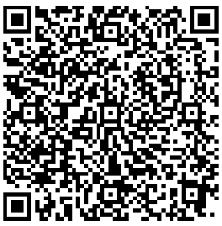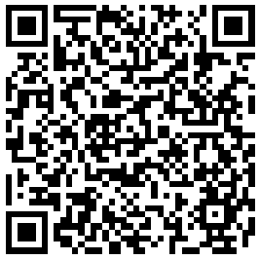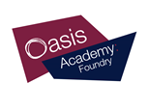

**Topic**

Our topic this half-term is ‘Pharaohs’. This is where we explore life in Ancient Egypt, their daily life, the ritual of mummification, writing in hieroglyphics and create our very own Egyptian masks.

**Reminders/ extra curriculum/ PE**

* PE on **Wednesdays** and **Thursdays** - Please make sure your child is wearing the correct PE kit otherwise they will miss out on the session.

**Homework**

Homework is due every week by **Wednesday**. It is your responsibility as a parent to check your child has completed and brought in their homework on time.

**Home reading**

Pupils are expected to read every night for **15 minutes** and write a comment in their **reading logs**. A reading log register is taken every day to ensure your child is reading at home.

Autumn 1 - Pharaohs!

Year 5